Laporan Quiz 4 PMC

1. FlowChart

1. 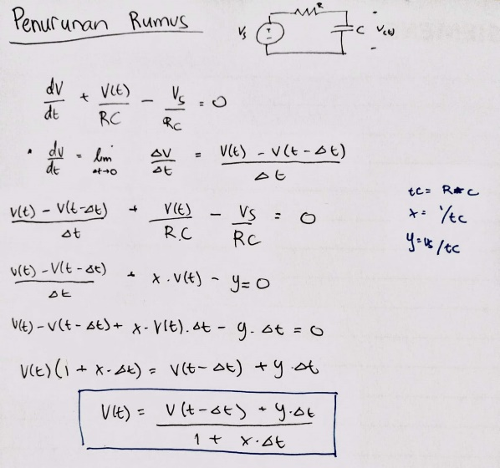Penurunan Rumus Tegangan di Kapasitor
2. Grafik